Tom Petty – Mary Jane's Last Dance
YAM:Wurli - Bank N11 – 1.vibes 2.harmonica 3.chorus pad
Vibes | Intro with vibes (8 bars)
Harmonica ----------> | Verse (4)  Harmonica (4)  Verse (4)  "movin'...on" (4)
 | Chorus (8)
Harmonica ----------> | Harmonica (4)
 | Verse (8) !!
 | Chorus (8)
 | Guitar solo verse (8)
 | Verse (8)
 | Chorus (8)
Harmonica ----------> | Harmonica twice (8)  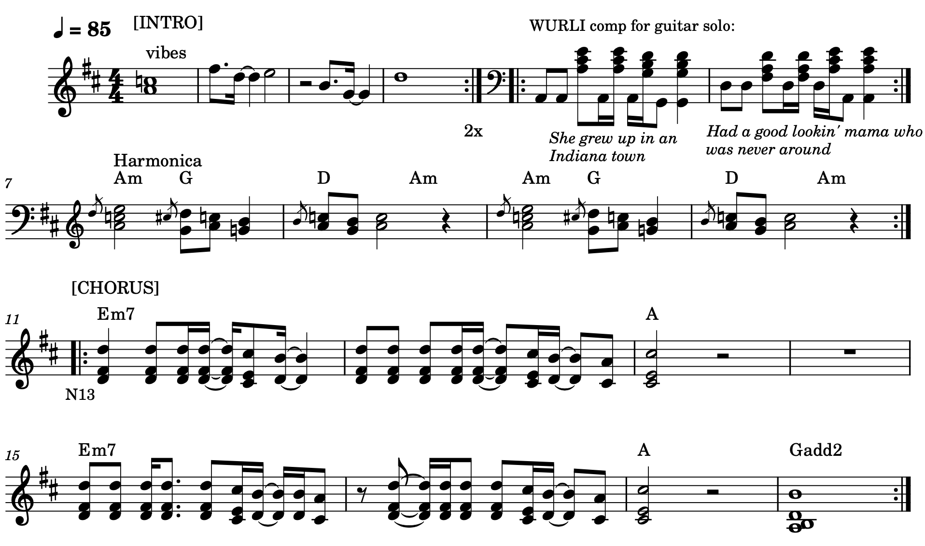  Guitar solo to fade

